**STREAMLINED PROCESSES FOR RENDERING:**

This is a detailed list of strategies that I have discovered over the course of this semester as being the most effective way to consistently produce high quality photogrammetric models as quickly as possible.

This list assumes that the reader will be using Photoscan, which has proven to be the most effective software for this type of work. ReMake is generally not recommended as it has a cap on the number of photos it can take at a time. Also, it consistently rendered with more holes than Photoscan did.

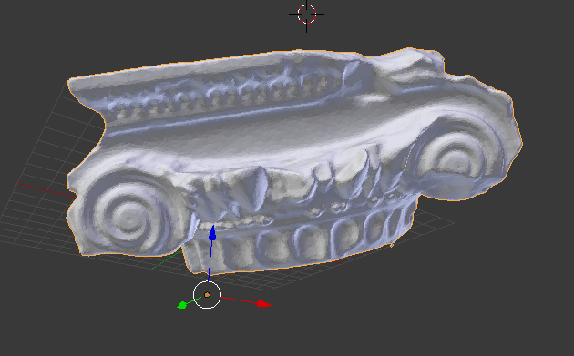

Here is a Photoscan example, where the model rendered watertight with zero holes and a high quality surface, even at lowest settings.

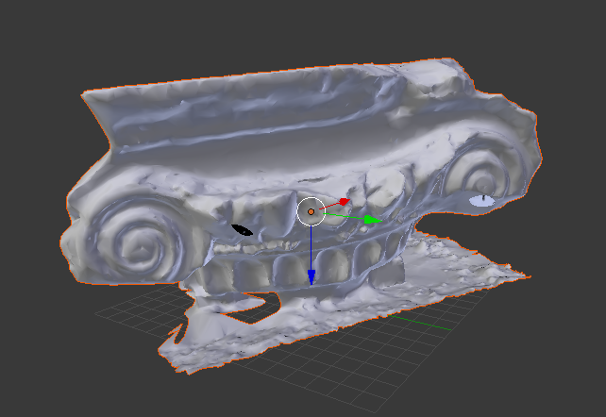

In comparison, here is a ReMake example, where there are many holes (the most prominent being at the bottom), in addition to an uneven surface texture. This model also required more clean up in post production, as the “floor” materialized in the final render as debris that needed to be removed. While this also happens in Photoscan, it is harder to remove in Remake due to the “floor” being attached to the actual object of interest in the final 3D model.

**SANDBOX -** While it would be ideal to have a license with the Hoffman2 Cluster for speedy Photoscan rendering, the next best thing is to use the workstations Oberon, Phobos, Calypso, and Janus, as they have been recommended by Bruce to be okay for long stretches of rendering, in addition to having Photoscan installed. Using other workstations to render things for a couple of days at a time often throws a wrench into the workflow of others working on the same station, so these four computers have been specifically dedicated to long renders / remote access logins. One of the biggest issues I had in both the Sandbox and SIL was that I could sometimes not login to a workstation because one person would already be working there when I stopped by.

**SIL -** This space only has two computers with Photoscan installed, and they are both Mac Pros: SIL 1 and SIL 2. These computers rendered at roughly the same rate as those in the Sandbox, though it was difficult to check back on the renders as there would often be people at the workstations when I came to check. I believe this happened more frequently than the Sandbox due to the fact that there were only two workstations capable of rendering.

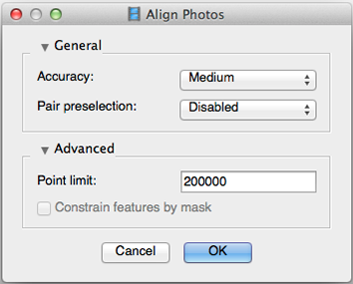

**Photoscan Tips -** To minimize the amount of time spent beginning each phase of the rendering process in Photoscan (of which there are several that each last a number of hours), I found it best to set up a Batch Process that automated all the steps to execute themselves in order, as well as save at the end of each step. This is incredibly easy to set up and I wish I learned how to do it sooner. In the Batch Process editor, I would proceed to adjust all settings to reflect their lowest value (to save time) EXCEPT the Align Photos setting, which I would leave at Medium, because this first step sometimes would result in an irregular model if too low.

**Known Issues -** I have yet to find a reliable way to import the photogrammetric model with all its materials properly mapped into Unity. The only working solution I have at the moment is to import an entire .blend file into the Unity asset folder and open the pre-mapped material there. To explain, every photogrammetric model that I’ve exported from either Photoscan or ReMake results in package with an .obj, a .mtl, and a small number of image texture maps in the form of .pngs. The model is broken up into a number of parts (usually 3 or 4), and these parts need to be matched with their corresponding image texture. Once they’ve been assembled in Blender then brought into Unity they seem to show up fine. I believe that in the future it would be beneficial to use another program, such as ZBrush, in order to export a single image texture map. This just makes the Unity material workflow easier to handle. Also, Unity works best when I decimate all models to be no more than 65,534 triangles. Smaller the model, the better.

I’ve also had some unique problems with some renders, such as with C08 and C12. For some unknown reason, C08 rendered like this:

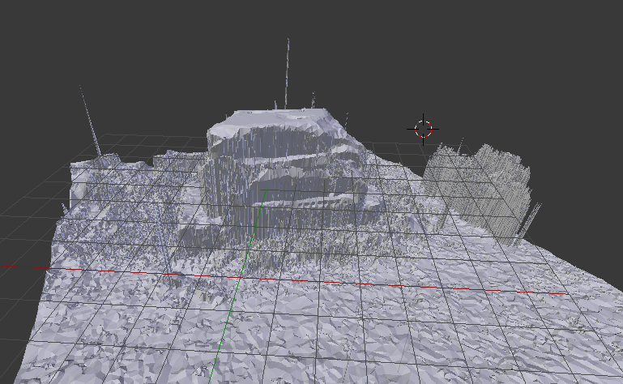

For some reason, the .obj did not appear to be this way when I was viewing it in Photoscan. It was only upon export that it got messed up like this…? I believe this happened because I did not adjust the Align Photos settings to be high enough (I think Medium quality is the minimum for a successful render).

Also, C12 rendered in a mysterious way, where “two” objects were identified in the photo collection after a dense point cloud was made. I’m not exactly sure what caused this problem, but I suspect it may have something to do with the way these ruins were photographed.

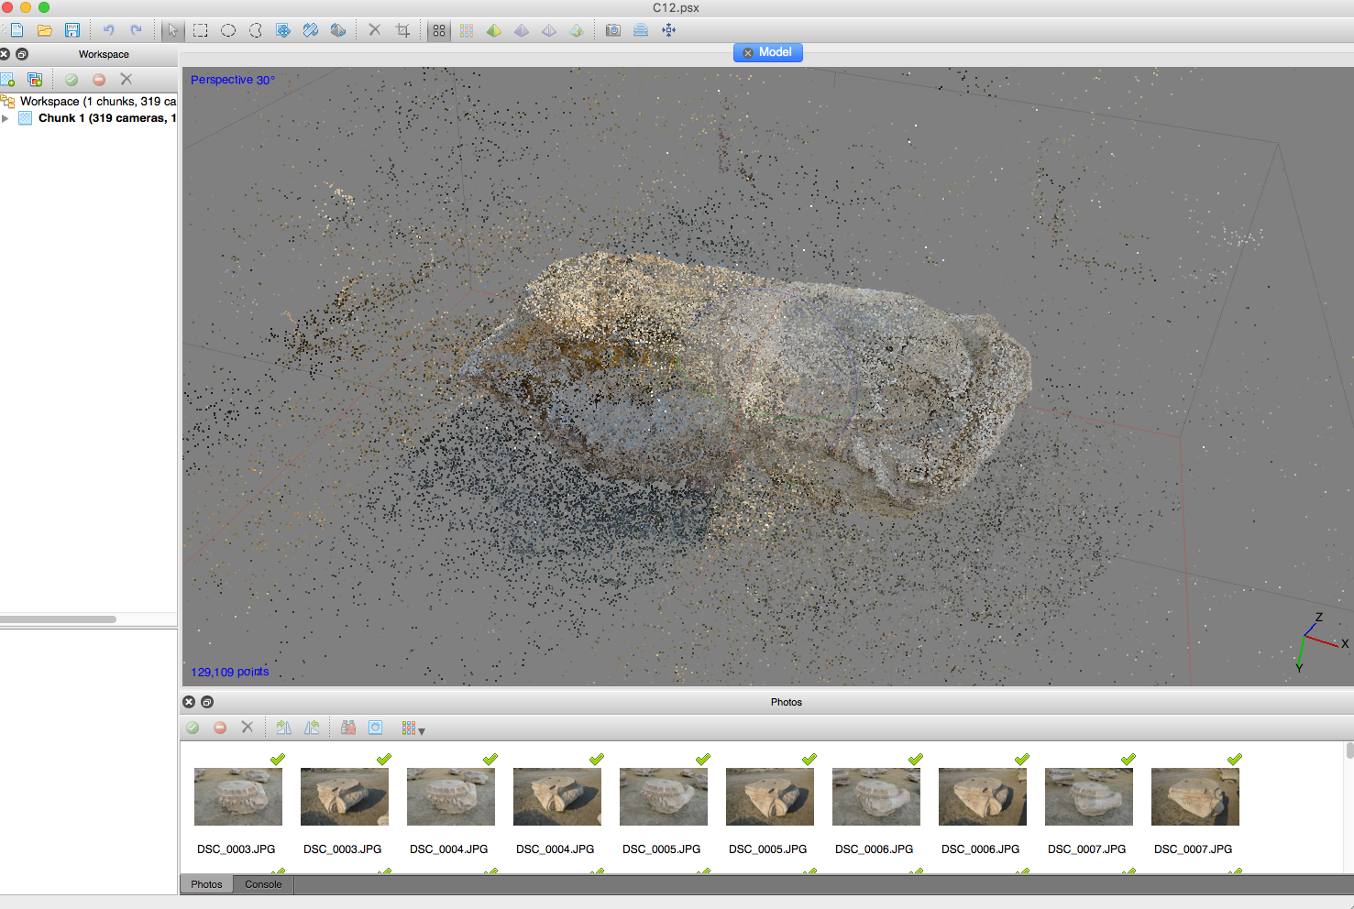

**Final Thoughts -** For the future, I would suggest experimenting with the way a model is exported from Photoscan. While I was exporting .objs this whole time, it may be the case that .dae or .svg may fare better in the transition from Photoscan -> 3D editing software -> Unity. The right formula needs to be figured out in order to truly streamline this process of rendering at UCLA.